**CSE499B**

**System Design**

knowledge distillation in Stable Diffusion model for image generation

Tawsif Mahmud-1912411042

Jiaul Haque Saboj-1912065042

Sadia Sifati Shammee-1912304042

System Design:

knowledge distillation in the Stable Diffusion model for image generation involves several components that work together to produce a smaller, more efficient student model. The teacher model, which has already been trained on a large dataset of high-quality images, serves as the "teacher" in the knowledge distillation process. The student model is a smaller, simpler model that is designed to mimic the output of the teacher model. The main components of the system design are:

The pre-processing module is responsible for collecting a large dataset of high-quality images and preparing them for training the student model. This includes tasks such as resizing the images to a uniform size, normalizing the pixel values, and splitting the data into training and validation sets.

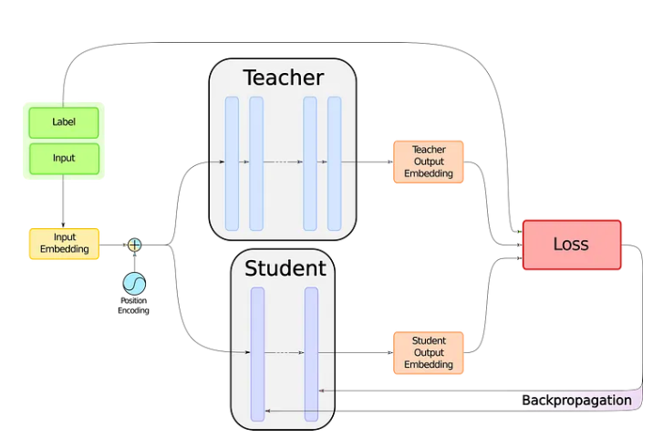

The teacher model module is responsible for loading the pre-trained teacher model and using it to generate a set of intermediate representations of the input images. These intermediate representations, known as the "teacher embeddings," serve as the targets for the student model.

The student model module is responsible for designing a smaller, simpler model that can generate images with similar quality as the teacher model. The student model takes as input a noise vector and a set of teacher embeddings, and outputs an image. The design of the student model is critical in achieving efficient knowledge distillation, as it should be able to generate high-quality images while using fewer parameters and less computation than the teacher model.

The knowledge distillation module is responsible for training the student model using the teacher embeddings as targets. The goal of this training is to minimize the difference between the output of the student model and the teacher embeddings. The module uses a loss function that takes into account both the difference between the output of the student model and the teacher embeddings, and the difference between the output of the student model and the ground truth images. The module also includes techniques such as distillation temperature and attention transfer to improve the quality of the generated images.

The evaluation module is responsible for evaluating the performance of the distilled student model compared to the original teacher model. This includes metrics such as image quality, computational efficiency, and scalability. The module also includes visualization techniques such as t-SNE and PCA to analyze the similarity of the teacher embeddings and the student embeddings.

The deployment module is responsible for deploying the distilled student model for image generation tasks. This includes integrating the model with a user interface, setting up a server for inference, and optimizing the performance of the model for different hardware and software configurations.

The system design for knowledge distillation in the Stable Diffusion model for image generation involves several components that work together to produce a smaller, more efficient student model. The pre-processing module prepares the image dataset, the teacher model module generates the teacher embeddings, the student model module generates the images, the knowledge distillation module trains the student model, the evaluation module evaluates the performance of the distilled student model, and the deployment module deploys the model for image generation tasks. By using this system design, we can achieve efficient and scalable image generation using the powerful Stable Diffusion model.